Chandrayaan 3 details -

How much time will it take to reach Moon ?

40 days. Soft landing of Chandrayaan 3 planned at 5.47 pm on August 23, said ISRO chief (S. Somnath.).

Why will it take so much time to reach Moon?

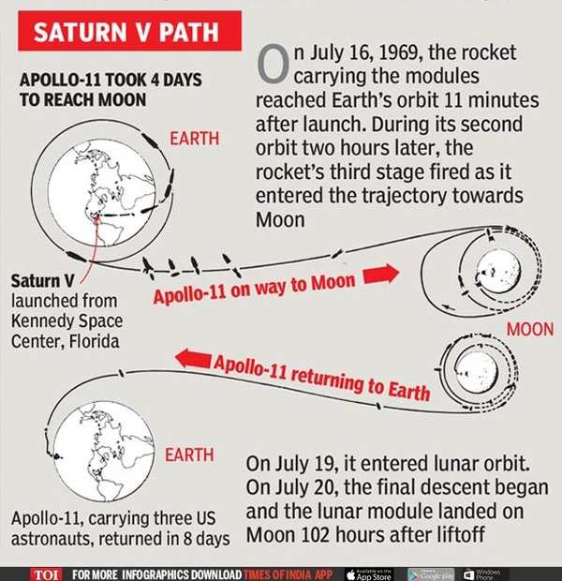

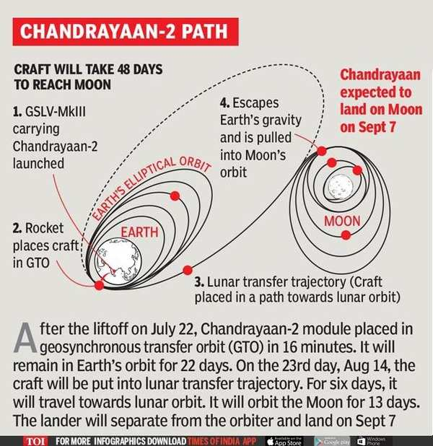

***India does not have a rocket powerful enough to hurl Chandrayaan-2 on a straight path to Moon.*** It’s the reason Isro chose a circuitous route to take advantage of Earth’s gravity, which will help slingshot the craft towards the Moon. The role of GSLV-MkIII, with only 4-tonne lifting capability, was limited to putting Chandrayaan-2 (3.8 tonnes) in the geosynchronous transfer orbit.

Currently, the lunarcraft’s propulsion system is raising its orbit. Once the craft reaches its apogee (farthest point from Earth), and with added acceleration, the final orbit will become so stretched out that the farthest part will be very close to Moon’s orbit.

What will it do there ?

The mission objectives of Chandrayaan-3 are:

1. To demonstrate Safe and Soft Landing on Lunar Surface
2. To demonstrate Rover roving on the moon and
3. To conduct in-situ (surface’s) scientific experiments.

How long will it function (mission)?

According to ISRO, the Chandrayaan-3 lander and rover have been engineered to function for a single lunar daylight period, which roughly translates to about 14 Earth days. But it could function longer than that.